**FACTOM**

**COMMUNITY**

**Administration of governance and community documents**

**DOC 002**

|  |  |  |  |
| --- | --- | --- | --- |
| Document control matrix* | | | |
| **ENTITY/ENTITIES** | **PART OF DOCUMENT** | **APPROVAL TYPE** | **APPROVAL AUTHORITY FOR THIS DOCUMENT** |
| Standing parties** | No highlight | ⅗ ANO approval | Yes |
| Not applicable | Not applicable | Single entity approval | No |

* See [Doc 002 - Administration of governance- and community documents](https://docs.google.com/document/d/12nvQVDOoLFNtmV_jqFEeWo1Ixx3R08z4KqLNVEbDoU4/edit?usp=sharing), Chapter 3.

** See [Doc 001 - *Factom Governance*](https://docs.google.com/document/d/1RVaVR7lvfGgOBMG-7oca9TtpnR7qaEfr6XJVaZJwd3M/edit?usp=sharing), Definitions.

|  |  |  |  |  |  |
| --- | --- | --- | --- | --- | --- |
| VERSION | DRAFT DATE | DRAFT BY | CHANGES | APPROVED BY | APPROVED DATE |
| 0.4 | 2018-10-25 | The 42ND Factoid LTD | Document for ratification. | N/A | N/A |
| 1.0 | N/A | The Factom Guides | Ratified document. | Standing Parties | 2018-11-06 |
| 1.1 | 2018-12-09 | The 42ND Factoid LTD | Updated document references due to restructuring of the Factom Community Drive. Not other changes made to the document. | Not approved |  |
| 1.2 | 2020-03-07 | cryptologic | Removed guides from process | Standing Parties | 2020-03-21 |

# Introduction

* 1. This document (this “Document”) describes the process for creating, ratifying, amending and retiring Factom governance and community documents (hereinafter referred to individually as “Factom document” or “document” and collectively as “Factom documents” or “documents”).
  2. This Document is limited in duration and scope and is intended to remain in force until a more comprehensive administration system is developed and approved by the Standing Parties.
  3. The ratified Factom documents are listed in [Doc 000, Table 1](https://docs.google.com/document/d/1kr9IR4MhM-L9PCTY8YgEZRd5c-hyUp-SIs7mA2lDK9o/edit?usp=sharing). This table shall be updated when there is any change to the status of the Factom documents.
  4. The word “ratify” in the context of this Document is used to describe the approval process of a document by the Standing Parties, currently the ANOs. After a document has undergone the ratification process, it is referred to as “approved.”
  5. Capitalized terms used but not defined herein have the meanings ascribed to them in [Doc 001 Factom Governance](https://drive.google.com/open?id=1RVaVR7lvfGgOBMG-7oca9TtpnR7qaEfr6XJVaZJwd3M).
  6. Parts of this document refers to specific functionality in the “community forum”. If these specific functions are not available as described for any reasons, the standing parties may facilitate the voting process on a suitable community platform adhering to the process described in this document.

# 

# Ratification of Documents

* 1. A Standing Party may make a motion to ratify a document.
  2. Ratification of a document shall undergo two distinct phases:
* Ratification motion and review period
* ANO-vote
  1. The document creator or its representative with standing in the Factom protocol shall make the document available to the Standing Parties for review and thus officially makes the motion to ratify the document.
     1. The document shall be stored on the Factom governance Google Drive, in the folder [/XX-Draft-Documents/](https://drive.google.com/open?id=1QTvHAWw92swZnqblzNrSMHvcGOPsesM-).
     2. The document draft should be created in accordance with the document templates available in the folder [/2_Informational and Records/](https://drive.google.com/open?id=1owPqPrlv_KpQwSQr2J0ML0Uhdv4yqvvm) in the Factom governance google drive.
     3. The document shall be named in accordance with the following format:

“[Document name (including doc nr if existing doc)] - [Version X.X.X]”

E.g: “Doc 001 Factom Governance - Version 1.0.4”

* + 1. A “Timed Discussion Thread” shall be created in the Document Ratification subforum of the community forum with the tag “draft”. A short description of the document and why ratification is requested shall be included.
       1. When creating the Timed Discussion Thread, the “*This is a Document Ratification / Amendment*” option shall be selected, which will automatically invite all Standing Parties.
    2. The default discussion period shall be eight (8) days but can be extended or shortened using the built-in features of the Timed Discussion threads on the forum.
    3. The document creator shall have the right to edit the documents during the discussion period and shall record the version history in the document version log as described in Section 3.2. The first draft shall be labeled as “0.1” and the final version subject to voting shall be labeled as “1.0”.

Note: Upon successful ratification the draft version numbers shall be removed and only the version 1.0 (or for re-ratification of documents: x.0) shall be included.

* 1. Upon conclusion of the discussion period, the Timed Discussion software will invite ANOs to vote.
     1. The poll shall include the options of “yes” and “no” and only the ANOs will be able to vote. The poll shall be created without the option for votes to be changed once submitted and shall close after all ANOs have cast the votes or five (5) days after the poll has become open, whichever is earlier.
     2. The affirmative vote by three-fifths (3/5) of the ANOs shall be required in order for the document ratification process to be successful.
  2. The document shall become ratified and effective immediately after it has received the necessary ANO votes and shall be incorporated into the Factom document structure at the earliest convenience.
  3. Ratified documents shall be Factomized in accordance with the procedures set forth in [*Doc 211 Factomization Instructions*](https://docs.google.com/document/d/1RSRXaNz0RSILgzDwsThEC3ttWFNjauTkMikU3xWFuBo/edit?usp=sharing) and registered in [Doc 201 Verification hashes](https://docs.google.com/document/d/1gFguzGSbQ1l3xmE_nx3hq_hqd49KEvsOpGdty98Pyqo/edit?usp=sharing)*.*
  4. If the document fails to be ratified, it can be revised and resubmitted in the future.

# Control matrix & version history

* 1. Each Factom document shall have an approval matrix on page 2, in the format set forth below, which contains the information stating which parties in the Factom ecosystem are allowed to approve any changes to it.

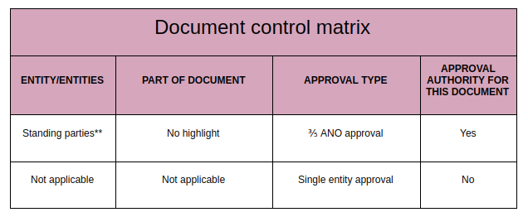

* 1. In addition to the control matrix, each document shall include a version history log in the format set forth below:

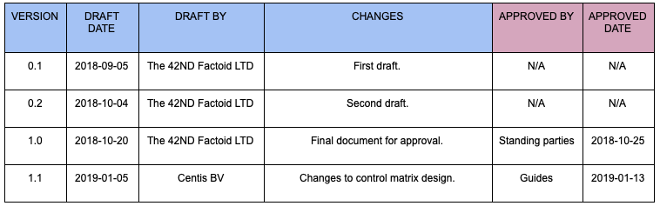

* + 1. The blue columns are used by the party who initially drafted the document or suggested changes to it at a later stage, while the pink ones are reserved for document approval by relevant parties.
    2. Version numbering
       1. The first digit (**1**.0) is increased if the document is “re-ratified” by ⅗ ANO vote.

*Example:* ***1****.0 ->* ***2****.0*

* + - 1. The second digit (1.**0**) is increased if the document is changed by a single entity with approval authority.

*Example: 2.****0*** *-> 2.****1***

# Amendment of Documents

* 1. A Factom document shall be amended in accordance with the rules set forth in the document’s control matrix described in Section 3 of this Document.
     1. The amendments that require a **single entity’s** approval can be made on an ad hoc basis and the community is not required to be notified of such an amendment.
     2. The amendments that require approval from the **Standing Parties** shall be made in accordance with the procedures set forth in Section 2 except that a Standing Party may propose changes to a ratified document by adding the changes directly to the document in the community governance folder as Google Document “suggestions.” The process required for ratifying new documents shall then be followed.

# Retirement of Documents

* 1. In the normal course of events where a document ceases to serve a substantive purpose in the community, it may be retired with the same level of approval needed to modify the document as set forth in its document control matrix. The retirement procedure for ratified documents shall follow Section 2 where a Standing Party shall propose the retirement of a specific document by posting a thread in the Factomize “Document Ratification” subforum with the tag “retirement.”

The same review period and voting process required by Section 2 shall be followed and upon a successful retirement vote the document shall be moved to the [/5_Retired Documents/](https://drive.google.com/open?id=1bsUb9l8xOE65gE6opoXFcJhIUj7faeFj) folder in the community governance Google Drive structure.